# **Sponsored Brand Ads – Campaign Structure & Strategy SOP**

## **Objective**

This SOP defines the structure, purpose, naming conventions, and execution process for **Sponsored Brand (SB)** campaigns. The goal is to maximize **brand visibility**, **discoverability**, and **conversion efficiency** across search results and product pages, while utilizing both **headline banner ads** and **video ads**.

**Phase 01 – Brand Visibility & Discovery**

**1.1 Brand Impression Share Campaigns**

#### **Objective**

* Capture maximum share of impressions for branded search terms.
* Defend top of search placements against competitors bidding on brand keywords.
* Maintain brand dominance across headline and video ad placements.

#### **Campaign Naming Convention**

| **Campaign Type** | **Naming Convention** |
| --- | --- |
| Headline Ads | PN-BrandImp-HL-BrandedKWs-TOS-Date |
| Video Ads | PN-BrandImp-Video-BrandedKWs-TOS-Date |

#### **Targeting & Structure**

* Manual Targeting: **Exact, Phrase, Broad Match**.
* Placement: **Top of Search**.
* Ad Formats: **Headline Ads & Video Ads**.
* Bidding Strategy: **Fixed Bids**.

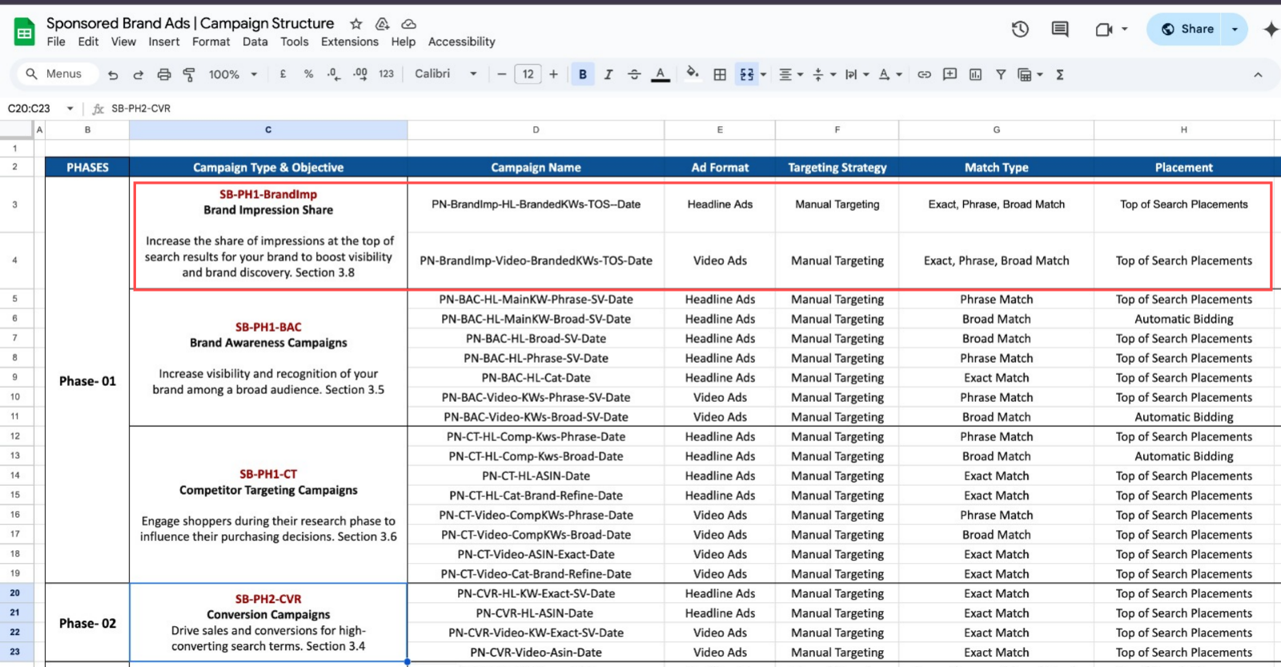

### **1.2 Brand Awareness Campaigns (BAC)**

#### **Objective**

* Introduce the brand to a **broad audience** using relevant keywords.
* Showcase key products with brand messaging to drive discovery.
* Drive traffic to the Amazon Brand Store for holistic brand experience.

#### **Campaign Naming Convention**

| **Campaign Type** | **Naming Convention** |
| --- | --- |
| Headline Ads - Main KWs | PN-BAC-HL-MainKW-Phrase-SV-Date |
| Headline Ads - Broad | PN-BAC-HL-Broad-SV-Date |
| Headline Ads - Category | PN-BAC-HL-Cat-Date |
| Video Ads - Main KWs | PN-BAC-Video-KWs-Phrase-SV-Date |
| Video Ads - Broad | PN-BAC-Video-KWs-Broad-SV-Date |

#### **Targeting & Structure**

* Manual Targeting: **Phrase & Broad Match**.
* Placement: **Top of Search**.
* Ad Formats: **Headline Ads & Video Ads**.
* Bidding Strategy:
  + **Broad Match Ads**: Use **Automatic Bidding**.
  + **Phrase & Exact Match Ads**: Use **Fixed Bids**.

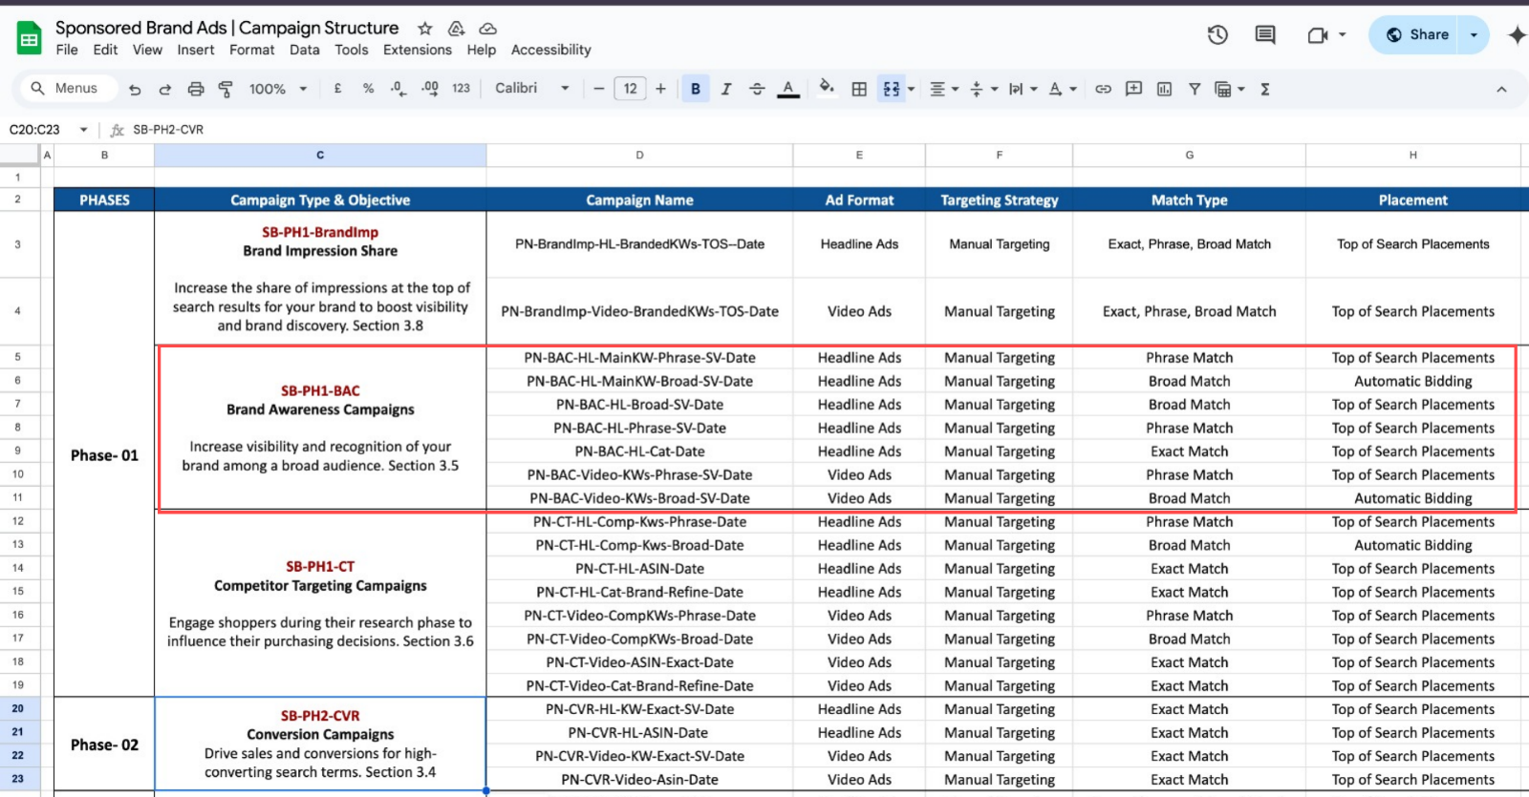

### **1.3 Competitor Targeting Campaigns**

#### **Objective**

* Capture competitor traffic by targeting competitor brand names, product categories, and ASINs.
* Influence shoppers during their product research phase.
* Position the brand as a strong alternative to competitors.

| **Campaign Type** | **Naming Convention** |
| --- | --- |
| Headline Ads - Competitor KWs | PN-CT-HL-Comp-Kws-Phrase-Date |
| Headline Ads - ASIN Targeting | PN-CT-HL-ASIN-Date |
| Headline Ads - Category Refined | PN-CT-HL-Cat-Brand-Refine-Date |
| Video Ads - Competitor KWs | PN-CT-Video-CompKWs-Phrase-Date |
| Video Ads - ASIN Targeting | PN-CT-Video-ASIN-Exact-Date |
| Video Ads - Category Refined | PN-CT-Video-Cat-Brand-Refine-Date |

#### **Targeting & Structure**

* Manual Targeting: **Phrase, Broad, Exact Match**.
* Placement: **Top of Search**.
* Ad Formats: **Headline Ads & Video Ads**.
* Bidding Strategy:
  + **Broad Match**: Use **Automatic Bidding**.
  + **Phrase & Exact Match**: Use **Fixed Bids**.

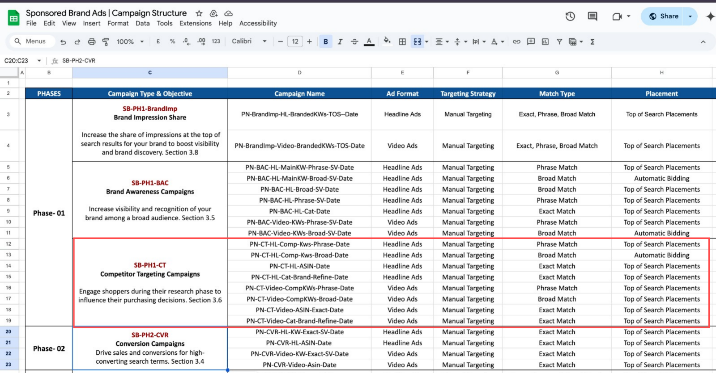

## **Phase 02 – Conversion Optimization**

**2.1 Conversion Campaigns (CVR Focus)**

#### **Objective**

* Drive conversions by **targeting high-intent keywords** and **ASINs** identified in discovery & competitor campaigns.
* Focus on **Top of Search** placements for maximum conversion potential.
* Retarget high-converting audiences who are already familiar with the brand.

#### **Campaign Naming Convention**

| **Campaign Type** | **Naming Convention** |
| --- | --- |
| Headline Ads - High-Converting KWs | PN-CVR-HL-KW-Exact-SV-Date |
| Headline Ads - High-Converting ASINs | PN-CVR-HL-ASIN-Date |
| Video Ads - High-Converting KWs | PN-CVR-Video-KW-Exact-SV-Date |
| Video Ads - High-Converting ASINs | PN-CVR-Video-Asin-Date |

#### **Targeting & Structure**

* Manual Targeting: **Exact Match**.
* Placement: **Top of Search**.
* Ad Formats: **Headline Ads & Video Ads**.
* Bidding Strategy: **Fixed Bids**.
* Focus: Use keywords & ASINs from **Phase 01 (Discovery)** with high conversion rates.

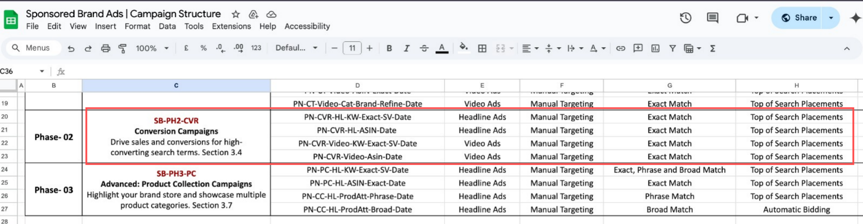

## **Phase 03 – Advanced Product Collection Campaigns**

### **3.1 Product Collection Campaigns (Store Traffic Focus)**

#### **Objective**

* Drive traffic to the **Amazon Brand Store** and showcase multiple product categories.
* Maximize cross-selling and brand storytelling.
* Leverage high-traffic keywords and product attributes to promote full product catalog.

#### **Campaign Naming Convention**

| **Campaign Type** | **Naming Convention** |
| --- | --- |
| Headline Ads - Product Collection | PN-PC-HL-KW-Exact-SV-Date |
| Headline Ads - ASIN Targeting | PN-PC-HL-ASIN-Exact-Date |
| Headline Ads - Product Attribute Targeting | PN-CC-HL-ProdAtt-Phrase-Date |
| Product Attribute Broad | PN-CC-HL-ProdAtt-Broad-Date |

#### **Targeting & Structure**

* Manual Targeting: **Exact, Phrase, Broad Match**.
* Placement: **Top of Search**.
* Ad Formats: **Headline Ads** only.
* Bidding Strategy:
  + **Broad Match**: Use **Automatic Bidding**.
  + **Phrase & Exact Match**: Use **Fixed Bids**.

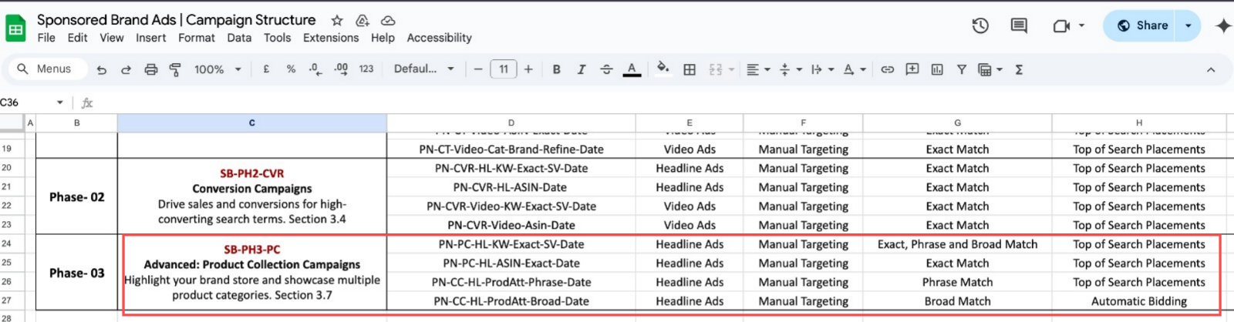

## **General Rules Across All Phases**

| **Element** | **Rule/Best Practice** |
| --- | --- |
| Naming Consistency | Follow the standard naming convention to ensure clarity in reports and tracking. |
| Budget Allocation | Prioritize awareness in Phase 01, optimize for efficiency in Phase 02, and invest in long-term brand building in Phase 03. |
| Creative Rotation | Refresh creative (headline copy, video assets) at least once per quarter to avoid ad fatigue. |
| Keyword Harvesting | Move high-performing keywords and ASINs from discovery to conversion campaigns. |
| Placement Focus | Top of Search always prioritized for Headline Ads. |
| Data Review Frequency | Weekly check on key metrics (impressions, CTR, CVR, ACOS). |

## Sponsored Brand Campaign Structure Template

[Sponsored Brand Ads | Campaign Structure](https://docs.google.com/spreadsheets/d/1Q1jqjuewUuWhGuN0mTUltGZvi6iI91jpa1DHy6g3nk0/edit?gid=1003023760#gid=1003023760)